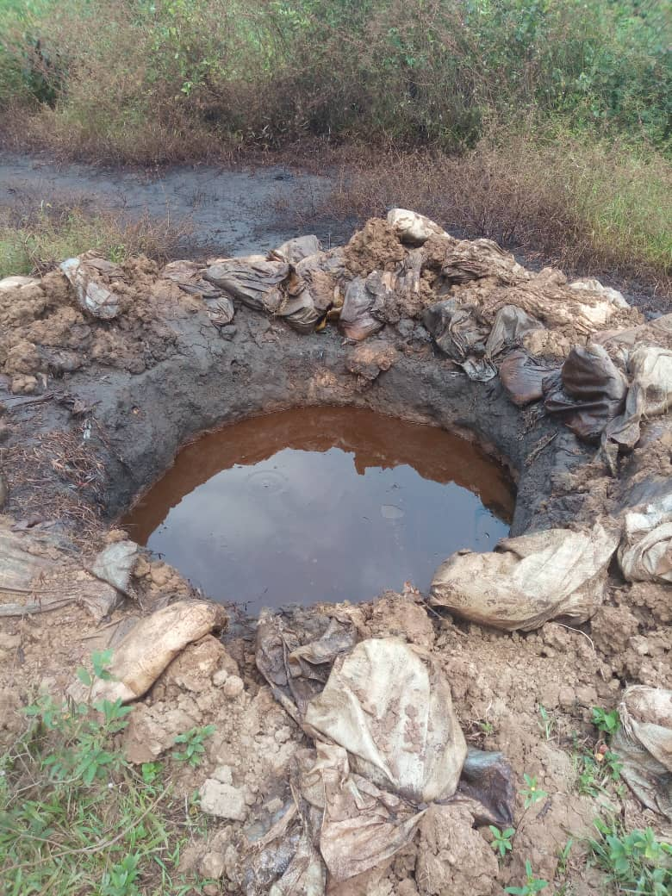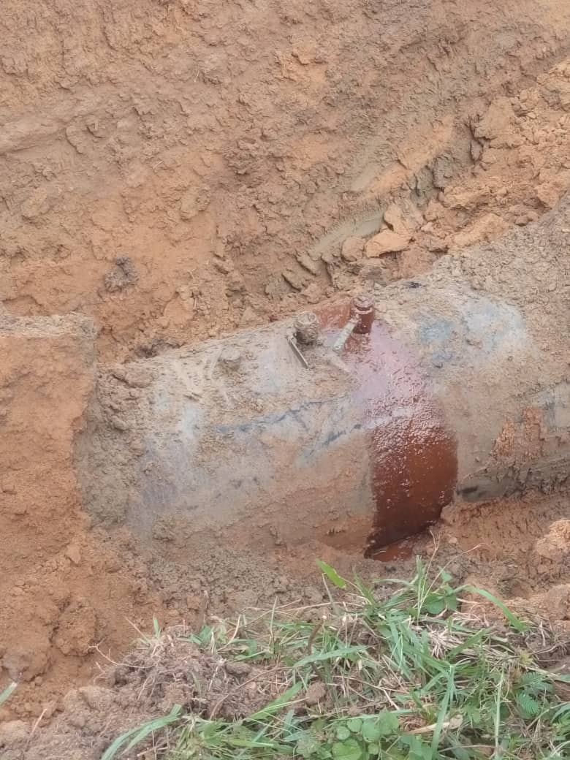
Figure 1. Ditch filled with Crude oil Fig.2. Arrows showing three spill points
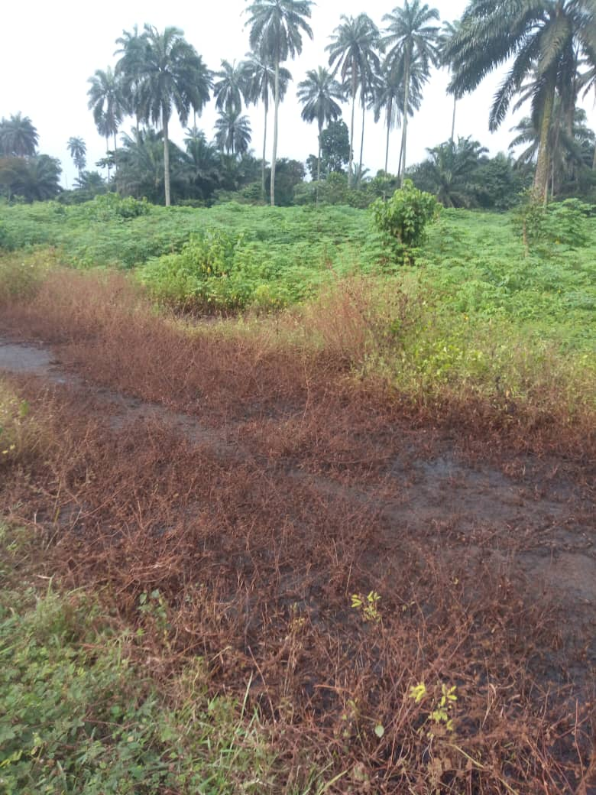
Figure 3 showing Impacted Area (SPDC’s ROW and a Nearby Farmland)

